***Urgent issues***

1. Orders are coming to partner/vendor when the customer order payment is failed, it should consider as ordered only after the successful payment (confirmation of payment from PayU API we passed). The same issue for the app as well. This already reported before.

Whereas the order is showing correctly in the dashboard. But in the new order details, it is showing all the orders whose payments are failed or customer came back from the payment method. Not solved yet - DONE



1. When the order is cancelled by the customer before the change of shipment status, why it is showing under orders? It should be removed from the list. This also reported before. – Not solved yet DONE
2. Coupon code changes.
   1. Show and hide in app – enabled, but used for active or inactive. Active and inactive is different and show and hide is different. Show and hide is only to show in app or not, if it is hide, it doesn’t mean that it is inactive, it will be active and will be used by specific customers
   2. Coupon code restriction to the selected customer numbers – restriction is showing in admin, but it is not restricted in app. The coupon should be restricted to the user only, for other users this coupon code should give not available. DONE
3. Sold by in the shipment label is taking the app registered user name, as per the initial discussion for this, it should take the customer entered name(i.e billing address name). same thing applicable for address to show in order details – Not yet done DONE
4. The order Label is not adjusted to the page and barcode is shrink (not clear to scan from courier partner), make sure it is covered 90% of the page as like below example. Please check and let me know if I need to get this done from Pickrr while getting label from them.

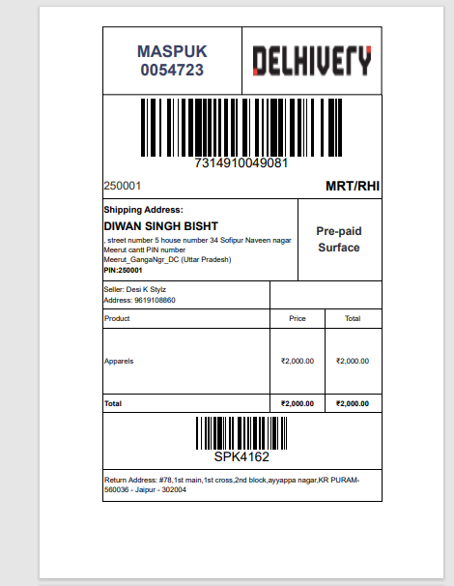

1. While passing the details to the courier partner for label, please give dimension as 10*10*2 DONE
2. Why payment method is showing as PayU? It should show whether it is online or COD right. – done DONE

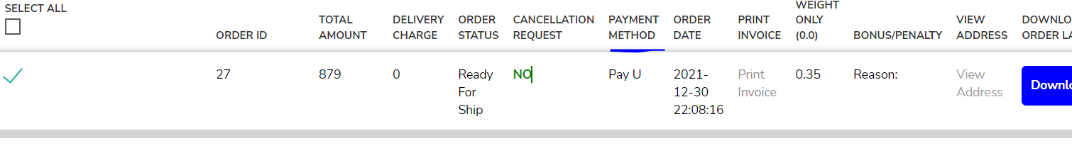

1. When the order is cancelled by the customer after online payment, return of the payment to the customer is not initiated – not done yet
2. Sharing of product is sharing all the sizes which are not available (inventory 0). Control this only to share the available sizes. This already reported before.DONE
3. Quantity available in home page is showing specific to one size. Remove this part of showing. Instead of this, show total available number of products under that special category in home page. Next to View All in braces. Example : **View All(23) DONE**
4. In app while showing the sizes (size selections), show available qty next to it. This already reported before.DONE
5. While placing an order make an e-Email as an optional entry in the shipping address.DONE
6. Track details are not clear here, shown with Track ID and link to track as like before. DONE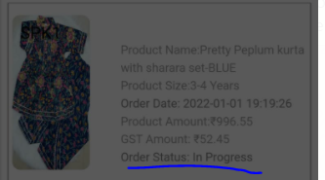
7. Correction of alert messages: DONE
   1. 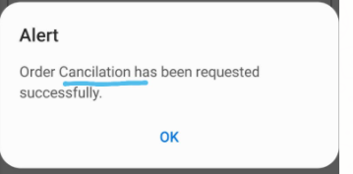Order Cancellation has been initiated successfully
   2. 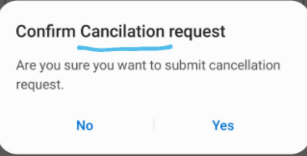Do you want to cancel the order?
   3. 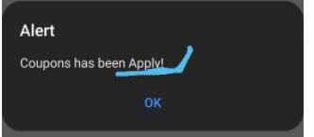 Coupon applied!!

***Not Urgent issues:***

* + 1. In Partner panel, future amount is still showing all the payment details. Reported before. This can be taken later as it is not urgent now. 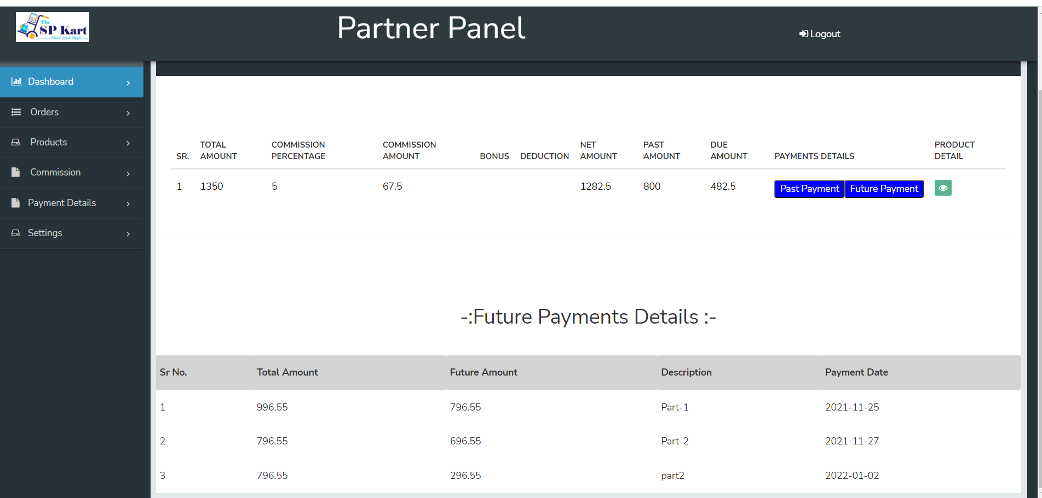
    2. In orders details, View address is not showing the pin code, please enable this.Done
    3. Coupon to give discount as a value as an option. Either % or value can be given.Done
    4. Billing address is not editable for phone number section while placing the order. This we agreed as a seller/resellers optional entry.
    5. In Admin Panel, the orders are showing, but actual order is not matching with it. And it is showing 0 in today’s order, but the order is available. Done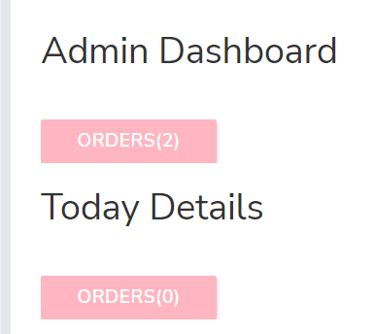
    6. After updating the order status, below message need to be removed (Sorry, no order to display).Done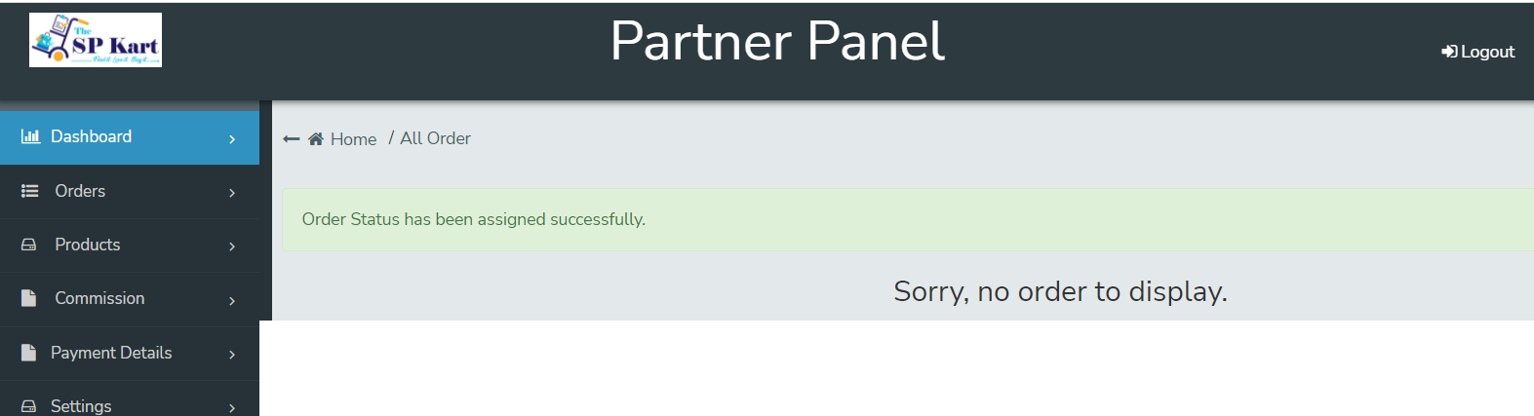
    7. In Partner/Admin panel, the multiple orders label download in one file need be given. This already reported before.
    8. Expected delivery date is coming from courier partner, we need to show the same dates in the order details in app and panel order details.Done
    9. When the order is cancelled by the customer after putting the order status to “Ready to ship” the shipment cancellation is should pass to the courier partner to cancel the pickup. And the same (cancelled by customer) need to be shown in the partner & admin panel and it should move to cancelled order list.Done
    10. After logged out and login with another user ID and pass in app, the old user Kart is showing under the second user login kart. How this is possible?.
    11. Sending notification failing for few customers, but not displaying for whom it is failed. Done